Add new responsibility in BI

Monday, August 11, 2014

09:30 AM

1. Launch Oracle Enterprise Manager 11g. [<http://10.10.130.31:7001/em>]
2. Login with weblogic username and password.

Machine generated alternative text:
610.10.130.31 
bifcunclaticn clcmain&typezcracle ias '7 
Informatica MBC Most Visited ODI Oracle 
ClearPeaks framework 
ORACLE 
Enterprise Manager llg 
Fusion Middleware Control 
8- 
Goog 
p 
Login to Oracle Fusion Middleware Control 
Farm Farm bifoundaton domain 
* User Name 
* Password 
Login I 

1. Expand **Business Intelligence** Node
2. Click on **coreapplication** link
3. Go to **Security** tab

Machine generated alternative text:
Enterprise Manager 1 lg Fusion Middleware control 
_ Topology 
Diagnosbcs 
Security 
Deplo yment 
Farm 
O coreapplication 
Business Intelligence Instance 
Change Center: Lock and Edi t Configuraton 
Farm bifoundaton domain 
Application Deployments 
WebLogic Domain 
Business In telligence 
co reap plication 
Essbase Servers 
Metadata Rev. tories 
ODI 
Availability 
Secure Sockets La yer 
Single Sign On (SSO) 
Capaci ty Managemen t 
Single Sign On 
SSO enables a user to log in once and gain access to all systems without being prompted to log in again at each of them 
authentcaton and will assume the user has already been authentcated by SSO. 
Enable sso 
SSO Provider Custom 
The SSO Provider Logon URL http://erpuatasi02.mbcgroup.IocaI:8020/ 
The SSO Provider Logoff IJRL http://erpuatasi02.mbcgroup.IocaI:8020/OA HTML/' 
Security Realm 
Go to the Oracle WebLogic Server Administrator Console to configure and manage the WebLogic security realm. 
Application Policies and Roles 
Configure and Manage Applicaton Policies 
Configure and Manage Applicaton Roles 

1. Click on **Configure and Manage Application Roles**

Machine generated alternative text:
O coreapplication G) 
Business Intelligence Instance 
Application Roles 
Applicaton roles are the roles used by security aware applicatons that are specific to the applicaton. These roles are seeded by applicatons in Single global 
These are also applicaton roles that are created in the context of end users accessing the applicaton. 
3 To manage users and groups in the WebLogic Domain, use the Orade WebLoaic Server Security Provider. 
Policy Store Provider 
yl Search 
Enter search kewvord for role name to query roles defined by this applicaton. Use application stripe to search if applicaton uses a stripe that is differerent 
Applicaton Stripe obi 
Edit. 
Delete... 
Create... 
Role Name 
BIAdminisfrator 
Create Like. 
Display Name 
al Administrator Role 
al Author Role 
BI Consumer Role 
al Apps System Role 
Descripton 
BIAuthor 
BIConsumer 
BIAppsSystem 
a IR epo si tor yManager 
allmpersonator 
EssbaseCaIcManager 
BIPDataModeIDeveIoper 
FEI ABSENCE MANAGEMENT TRANSACTION ANALYSIS 
FBI AGREEMENT TRANSACTION ANALYSIS DUTY 
yl Membership for BISystem 
DUTY 
BI Platform Repository ME 
al Impersonator 
Essbase Calculatons Man 
al Publisher Data Model D 
Absence Management Tre Analyzes Workforce absences transactonal information 
Agreement Transaction Al Analyzes Agreement transactional informaton 
Description 
Prin cipal 
BISystemLlser 
Displa y Name 
Type 
L' ser 

1. Click **Create** button to create a new responsibility as a Role in BI

Machine generated alternative text:
O coreapplication 
Business Intelligence Instance 
Applicaton Roles 
Create Application Role 
Create Application Role 
Gene ral 
Applicaton Stripe obi 
* Role Name 
Description 
Members 
An application role may need to be mapped to users or groups defined in enterprise LDAP server, or the role can be mapped to other application roles. 
Logged in as weblogic 
Aug 11, 2014 PM 
0K 
Cancel 
Add 
Delete... 
Name 
groups or applicaton roles added. 
Displa y Name 
Type 

Above form will create a new responsibility as a new Role in BI.

Make sure that the spellings are same as Oracle EBS responsibility,

Add specific groups, roles to give privileges to the newly created Role.

1. Click **OK** button to save the changes.
2. Add this newly created responsibility under BIConsumer Role as follows

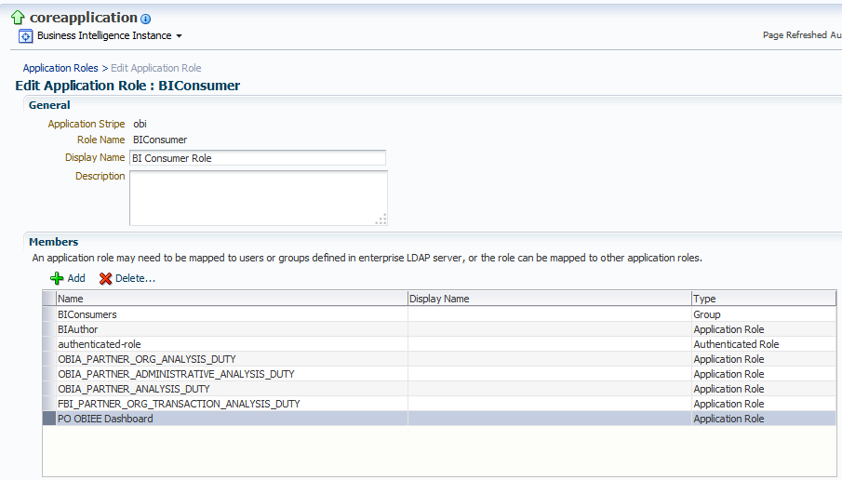

1. Need to restart BI Services to reflect these changes in Respository